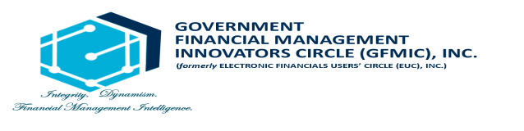

**ADVISORY**

The Government Financial Management Innovators Circle (GFMIC), Inc. would like to inform everyone that the 12th Annual National Convention (ANC) scheduled on June 23-25, 2021 is rescheduled on July 21-23, 2021 due to inevitable circumstances.

For your concerns, please contact us through email at [gfmic.inc@gmail.com](mailto:gfmic.inc@gmail.com) or at telephone numbers 09277945452 or 09658131185.

Thank you.